**How to save a document in Mr. Brosius Class**

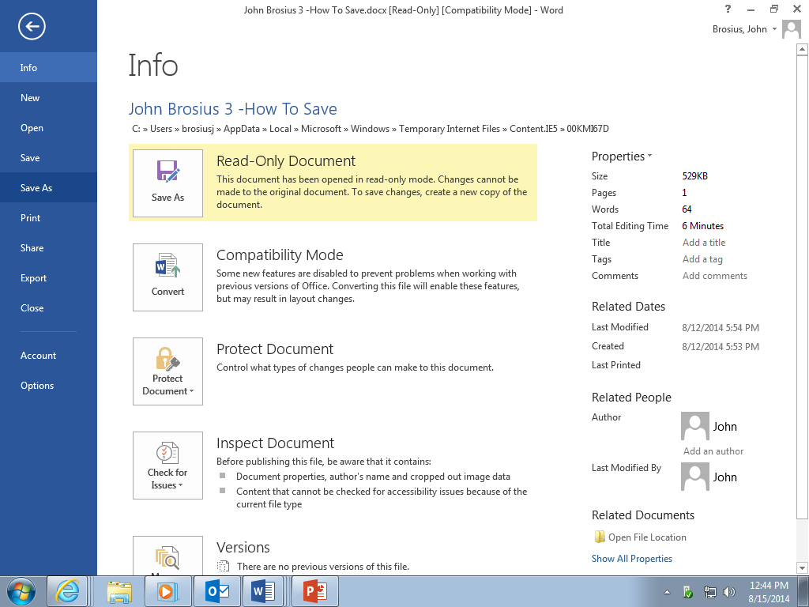

Click Office Button

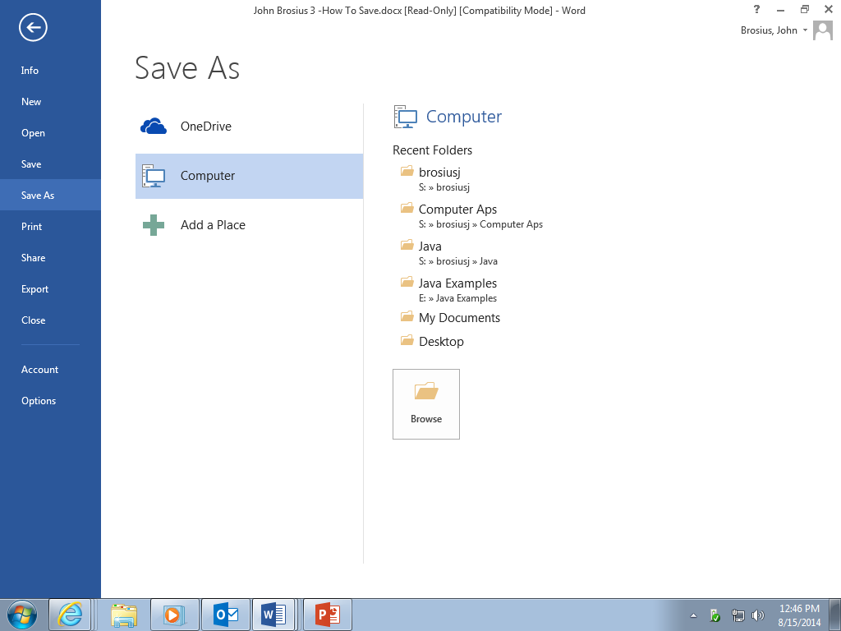

Click “**Save As”** and double click computer. This will take you to the drive that you want to save under.

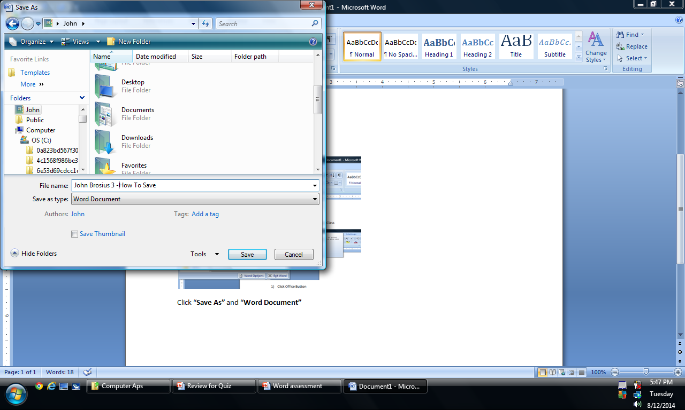

Go to **Documents,** Open file and Create **“New Folder”** name new folder **“Computer Aps I”,** Save file and all files with your name first the Period you are in and the name of the file.File name should be saved as **“Your Name 3-How To Save”.**